CS 315 Networks Lab1

Protocol 1: Application Layer - DNS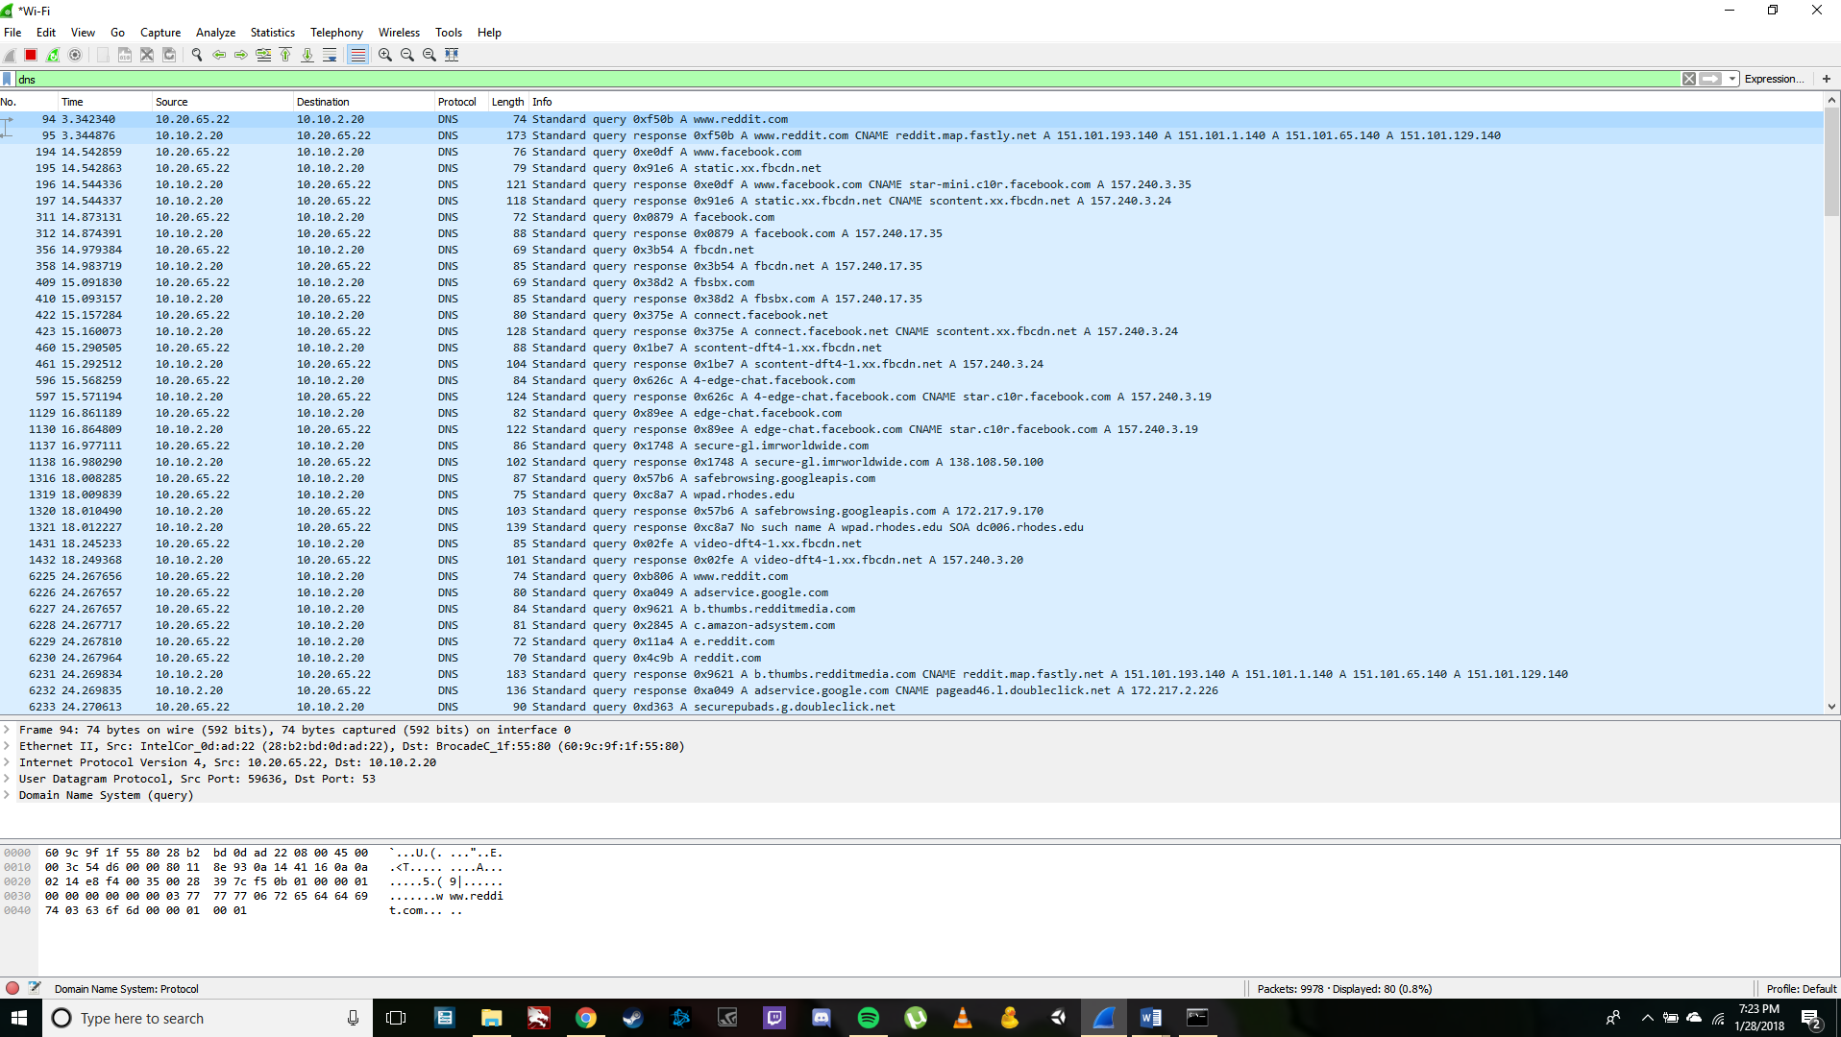

Domain Name System (DNS) is a hierarchical decentralized naming system for omputeres connected to the internet or private network. Associates various info with domain names assigned to each of the participating entities. Mainly it translates more readily memorized domain names to the numerical ip addresses needed for locating with the network protocols. Its been in use since 1985. It is used within the Application Layer

Protocol 2: Transport Layer – TCP

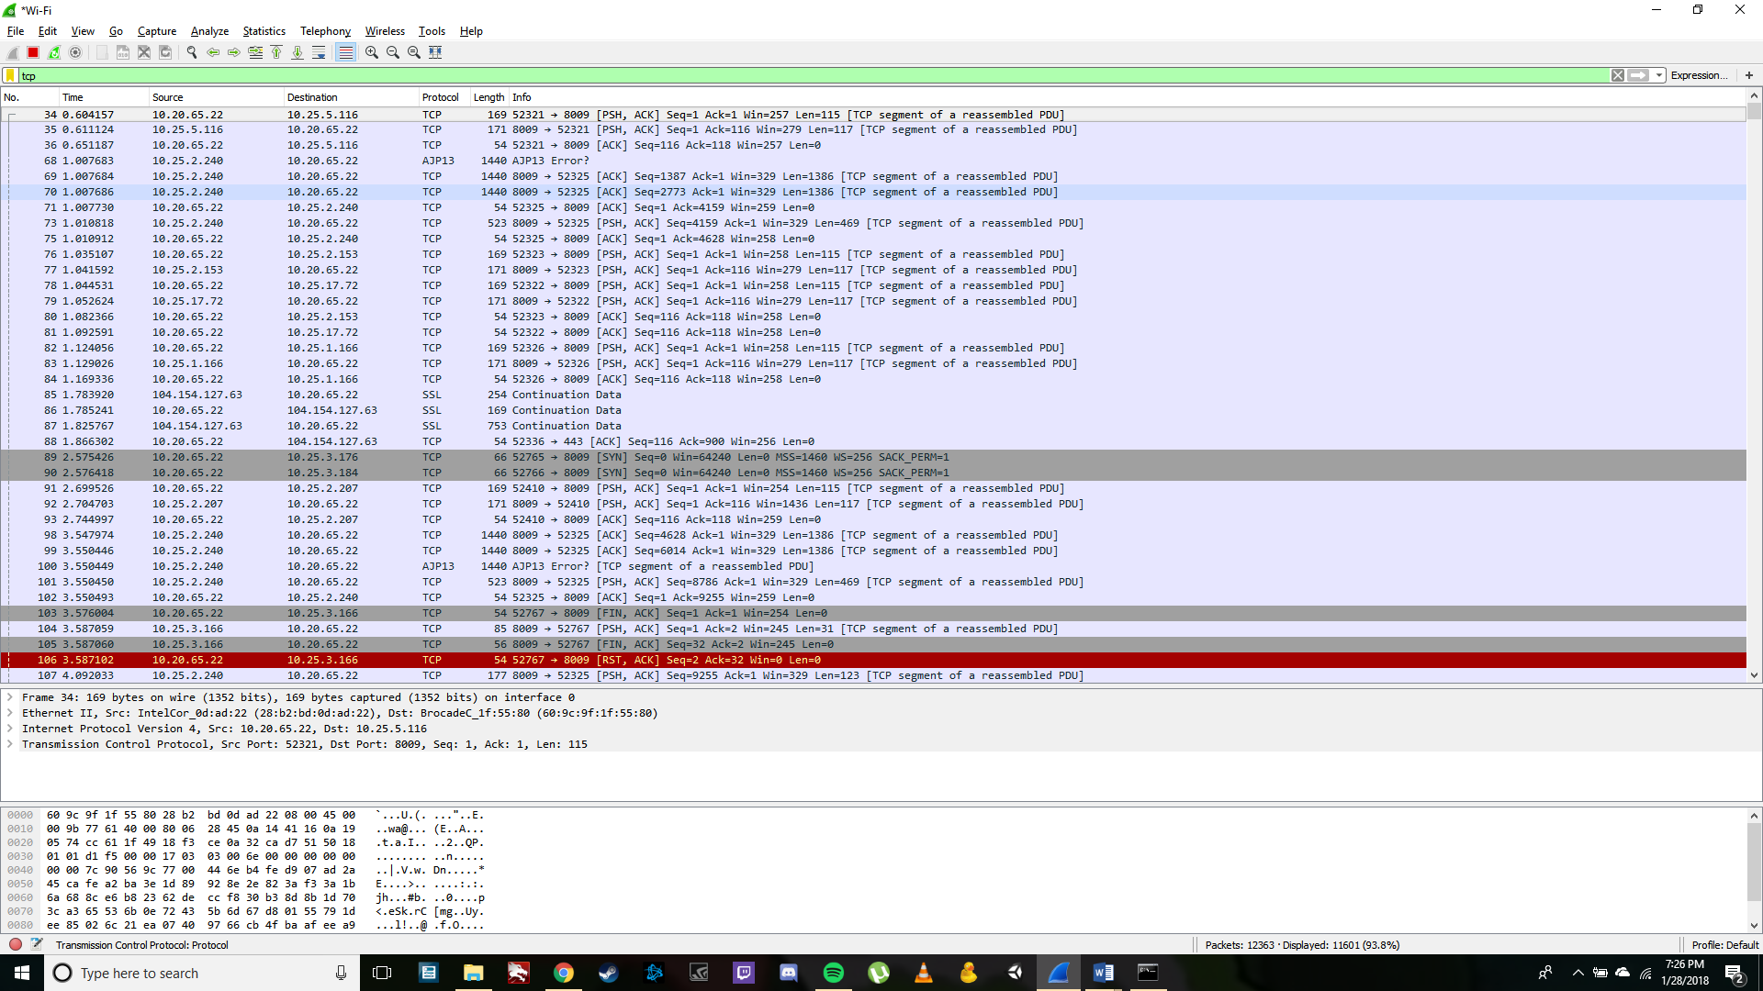

Transmission Control Protocol (TCP) is one of the main protocols of the internet protocols. TCP provides reliable, ordered, and error-checked delivery of a stream of octets between applications running on hosts communicating by an ip network. Major internet applications such as World Wide Web, email and file transfer rely on TCP. It is used in the Transportation Layer

Protocol 3: Network Layer – ICMP

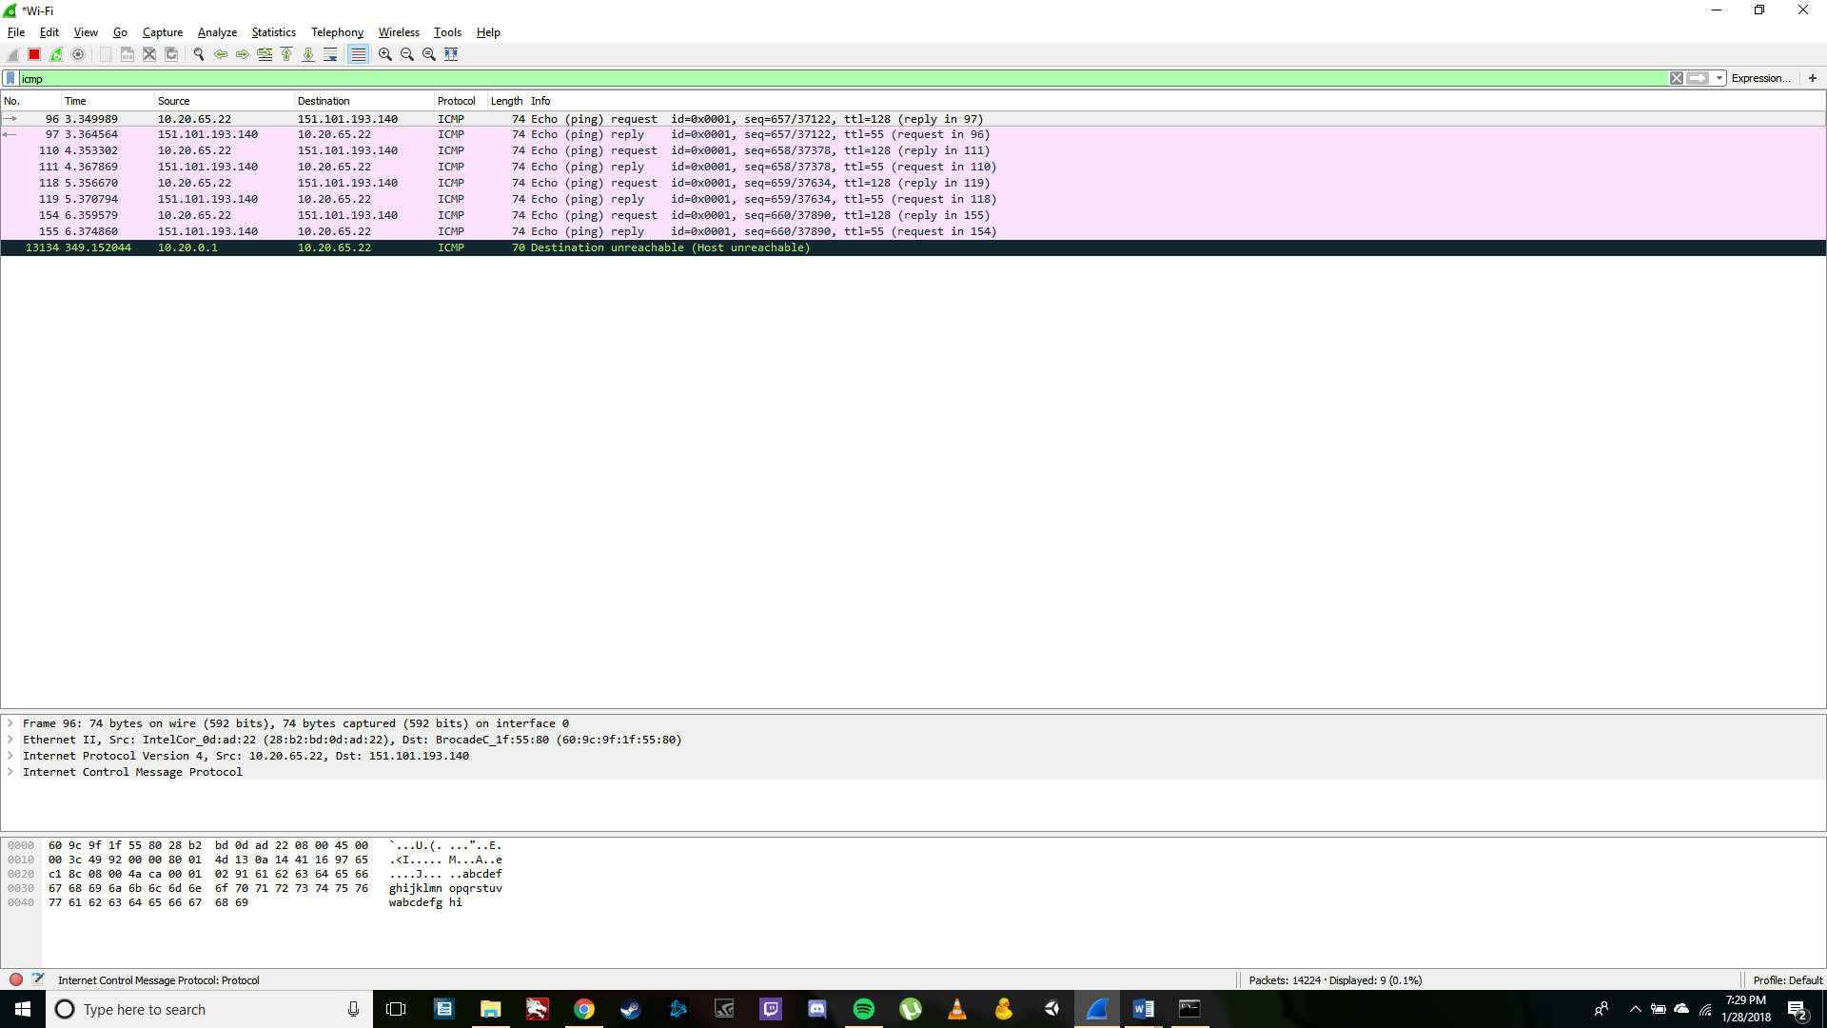

Internet Control Message Protocol (ICMP) is a supporting protocol in the internet protocol suite. It is used by network devices including routers to send error messages and operational information indicating that a service is unavailable or that a host could not be reached. ICMP differs from transport in that it is not used to exchange data between systems. It is used in the Network Layer

Step 4:

DNS packet detail

Source addr: 10.20.65.22

Destination addr: 10.10.2.20

Protocol: UDP (17)

Version: 4

Header Checksum: 0x8e84

Header length: 20 bytes

Type of Service: 0100 0101

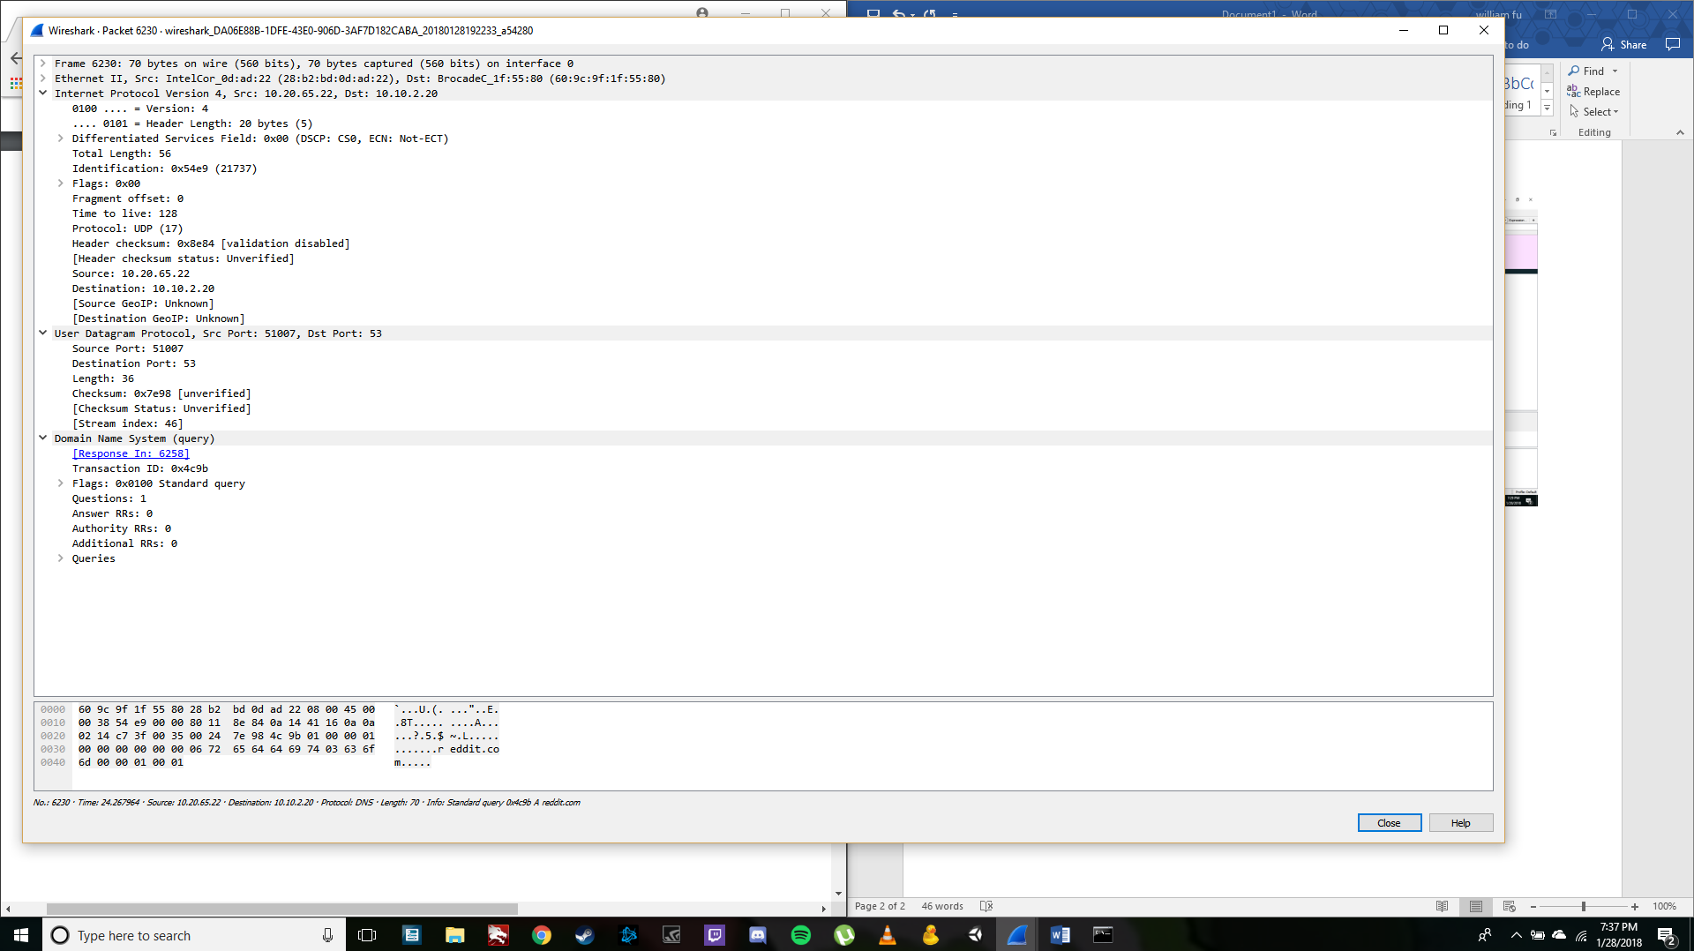

TCP Packet detail

Source addr: 10.25.2.240

Destination addr: 10.20.65.22

Protocol: TCP (6)

Version: 4

Header Checksum: 0x21f6

Header length: 20 bytes

Type of Service: 0100 0101

